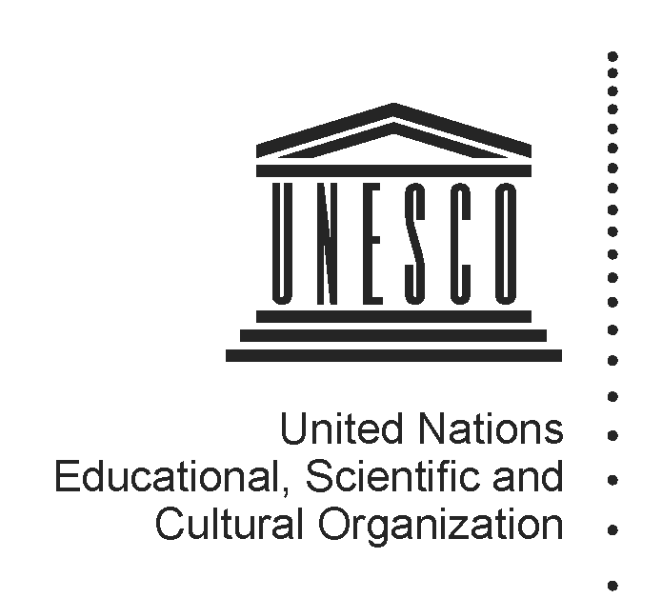 2014-2015
Mapping factsheet
Institutes and centres under the auspices of UNESCO
(Category 2)

Reference documents pertaining to the integrated comprehensive strategy for category 2 institutes and centres:

- 37 C/Resolution 93 (adopted on 19 November 2013)
- 37 C/18 Part I and its attachments
- 37 C/4 (Medium-Term Strategy) and 37 C/5 (Programme and Budget)

Full name of institute/centre and its acronym, if any | Arab Regional Centre for World Heritage (ARC-WH)
Name of the host Member State and city | Kingdom of Bahrain / Manama
Name of other participating/sponsoring Member State(s) | None
Date of approval for the creation by the General Conference and relevant resolution | 35th session of the General Conference (October 2009)  Resolution 35 C/20
Date of entry into force of the signed agreement with UNESCO | December 2011
Date(s) of the renewal of the agreement and relevant Executive Board decision(s) | December 2017
Is the present agreement in compliance with the integrated comprehensive strategy (37 C/18 Part I)? | No, but the necessary amendments will be made by the time of the next renewal, scheduled for 2017
Duration of the agreement | This Agreement is valid for a period of six years as from its entry into force (December 2011).
Thematic specialization | The ARC-WH is dedicated to the reinforcement of the implementation of the World Heritage Convention, in all its aspects, in the Arab Region. The ARC-WH aims at being a relay of the World Heritage Centre in the region and to contributing to the Global Capacity Building Strategy, in addition to the specific programmes it may wish to develop on its own.
Contribution to which UNESCO strategic objectives (37 C/4) and expected results at the main lines of action (MLA) level (37 C/5) | The Centre will be contributing to MLA 1 – Programme IV “Protecting, conserving, promoting and transmitting culture, heritage and history for dialogue and development” – ER1: Tangible heritage identified, protected, monitored and sustainably managed by Member States, in particular through the effective implementation of the 1972 Convention.
Contribution to the two global priorities of UNESCO – Africa and Gender Equality | Cooperation initiated between the ARC-WH and the African World Heritage Fund (AWHF) for activities in the seven African Arab countries covered by both centres.  Financial support of the ARC-WH to the safeguarding of the World Heritage Sites in Mali.  No information so far on how the ARC-WH deal with the global priority on Gender Equality.
Contribution to the implementation of sector-specific strategy of interaction with category 2 institutes/centres | The ARC-WH fully contributes to the implementation of the Culture Sector Strategy for category 2 institutes and centres (http://www.unesco.org/new/fileadmin/MULTIMEDIA/HQ/BSP/images/CLT_strategy_final_01.pdf)
Implementation strategy (200 words), should come from the agreement | The Centre’s mission is to strengthen the implementation of the 1972 World Heritage Convention in the Arab States region, by reinforcing the application of the decisions and recommendations of the World Heritage Committee for the benefit of World Heritage sites in the region.  The main objectives of the Centre are to act as a relay for the action of the World Heritage Centre and its partners in the Arab States region by federating regional energies around the conservation, promotion and presentation of the region’s cultural and natural heritage, in order to increase balanced representation of Arab States properties on the World Heritage List, promote better protection and management of such World Heritage properties, mobilize regional and international financial support for these purposes, and raise awareness of World Heritage in the region.  In support to these objectives, the main functions of the Centre shall be:  • The provision of information relating to the World Heritage Convention and its application, including development and management of an Arabic language web site, the translation and publication of relevant documents, and promotion of the establishment of new conservation programmes at universities, in all the Arab Region States;  • The provision of assistance to Member States of the Arab States region to improve their capacity to implement the World Heritage Convention (including understanding of World Heritage policy, concepts, rules of procedure, preparation of tentative lists, preparation of nominations, monitoring of state of conservation, education programmes, etc.) by facilitating organization of appropriate World Heritage training at ARC-WH's premises or anywhere else in the region, and responding to requests for assistance by Member States of the Arab States region;  • The provision of logistical and financial support for regional activities in support of the World Heritage Convention including hosting of meetings, conferences, training workshops or exhibitions in the region; the identification of appropriate facilities and services (lecture rooms, equipment, competent translators, etc. for planned meetings of UNESCO and other international institutions in the region, and the raising of funds to support World Heritage activities in the region.
Geographic coverage | The ARC-WH serves 19 States Parties to the Convention: Algeria, Bahrain, Egypt, Iraq, Jordan, Kuwait, Lebanon, Libya, Mauritania, Morocco, Oman, Palestine, Qatar, Saudi Arabia, Sudan, Syria, Tunisia, United Arab Emirates and Yemen.  Remarks  - (the Agreement, signed on 5 February 2010, does not include Palestine since the latter was not yet a UNESCO Member State)  - (the Agreement mentions the “Libyan Arab Jamahiriya” which has become since 2011 “Libya”)
Best practices in promoting South-South, North-South and triangular cooperation | Not yet evaluated
Governing Board | According to the terms of the Agreement (Articles I, III and VIII), the Governing Board is composed of:  Members with the right to vote  The Minister in the Government of the Kingdom of Bahrain with responsibility for Culture, or his/her representative, as Chairperson of the Governing Board;  A representative of the Ministry of Foreign Affairs of Bahrain;  A representative of each of the Member States from the “Arab States region” as defined in Article I of the Agreement, which shall send to the Director-General of UNESCO a notification, in accordance with the stipulations of Article III, paragraph 2, above; these Member States from the "Arab States region" having to be at the same time members of the World Heritage Committee at the moment of the formation of the Governing Board;  Representatives of a limited number of Member States, which shall send to the Director- General of UNESCO notification, in accordance with the stipulations of Article 3, paragraph 2, above in order to ensure, as far as possible, equitable geographical representation;  A representative of the Director-General of UNESCO.  Observers with no right to vote  A representative of each the Advisory Bodies to the World Heritage Committee .i.e. ICOMOS, IUCN and ICCROM;  A representative of the World Heritage Institute for Training and Research – Asia and the Pacific (WHITR-AP);  Member States referred to in Article III, paragraph 2, hereof but which are not members of the Governing Board.  So far the ARC-WHC has decided to limit the participation in the Governing Board meetings to:  The representative of the Ministry of Culture;  The representative of the Ministry of Foreign Affairs;  The representative of the DG of UNESCO;  The representative of each Arab State member of the World Heritage Committee;  The representatives of the Advisory Bodies to the World Heritage Committee (ICOMOS, ICCROM and IUCN).
Financial contributions of UNESCO if the agreement of institute/centre entered into force before 2013 when the General Conference approved the current integrated comprehensive strategy in its 37 C/Resolution 93 | Resources provided under Regular programme for:  (i) feasibility study  (ii) activities, implemented through contractual arrangements  (iii) participation in governing board meetings  (iv) renewal review assessment  (v) others (pls. specify) | Feasibility study  No financial contribution.  The feasibility study was carried out by an expert appointed by UNESCO but directly paid by Bahrain.  Activities, implemented through contractual arrangements  No financial contribution  Participation in governing board meetings  No financial contribution. The participation of the UNESCO representative is entirely covered by the ARC-WH  Renewal review assessment  No financial contribution. No renewal review so far.
 | Extra-budgetary | No financial contribution from extrabudgetary source
 | Total | 0
 | Centre’s budget and sources of financing | Regular Budget  EUR 2 million / year  Funding sources  Government of Bahrain
Has the institute/centre been providing biennial self-assessment progress report(s) to UNESCO?  If so, indicate the date of the last submission and provide the web link | No report submitted so far
Has the institute/centre been evaluated and/or audited?  If so, when and by whom? | No yet evaluated
Is the institute/centre considered as non-operational due to the absence of an agreement signed between UNESCO and a host country? | No
Responsible UNESCO Programme Sector and its implementing unit(s) | CLT/HER/WHC  Arab States Unit
Name and title of responsible officer(s) | Kishore Rao, DIR/HER/WHC
Name and title of sectoral focal point(s) for category 2 institutes and centres | Vesna Vujicic
UNESCO field office in contact with institute/centre | Doha Office
Name and title of field office focal point(s) | Anna Paolini, Director  Brendan Cassar, Programme Specialist
Name and title of UNESCO staff seconded to institute/centre, if any | No staff seconded
Relevant web-links for :  (i) UNESCO sector-specific web-page  (ii) Institute/centre dedicated web-page  (iii) Agreement with UNESCO  (iv) other | UNESCO sector-specific web-page:  http://whc.unesco.org/fr/centresdecategorie2/  ARC-WH dedicated web-page:  http://arcwh.org/  Agreement with UNESCO:  http://www.unesco.org/new/fileadmin/MULTIMEDIA/HQ/BSP/images/INSTITUT_BAHRAIN.pdf

