**Objective**:

The propose of this document to give a help for bidirectional-languages users with the support they need to mirror their pages easily & quickly.

The document will minimize effort for bidirectional-languages users to investigate how to mirror their pages as it will give details how can do that.

We select two files from “accordion” widget to start with:

**Widget Accordion:**

File “default.html”

The current page before mirror:

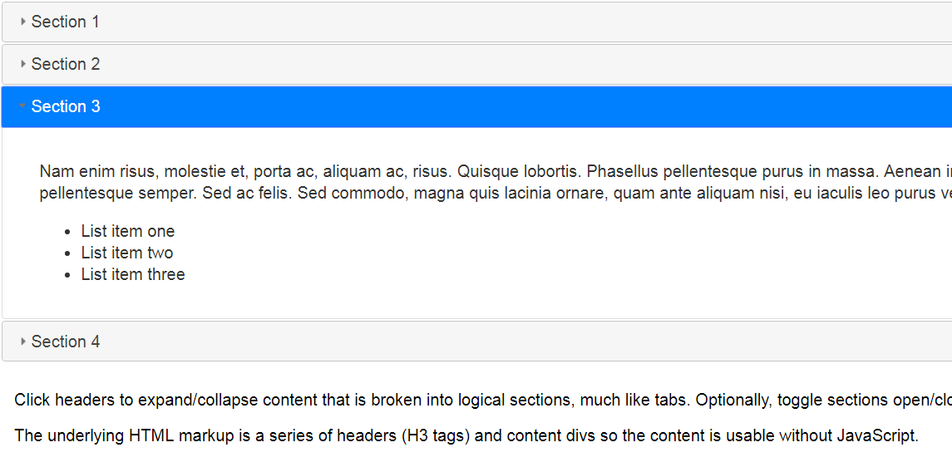

After mirror:

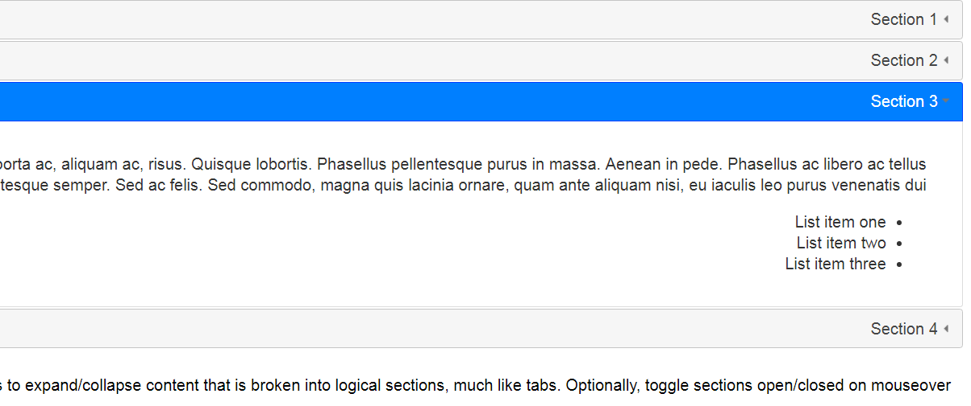

The change you need to do in the code as following:

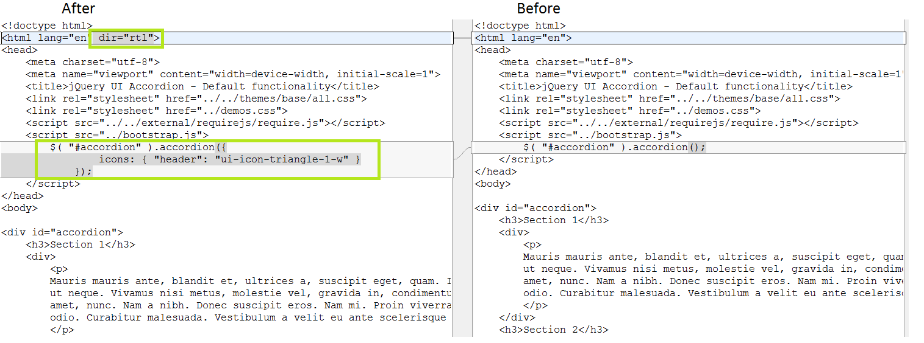

File “fillspace.html” :

The current page before mirror:

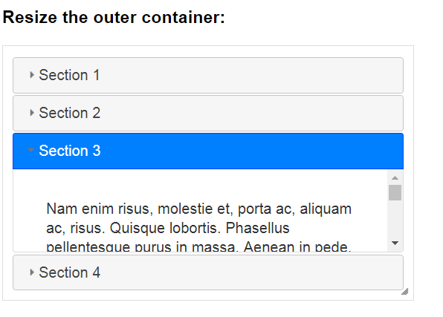

After mirror:

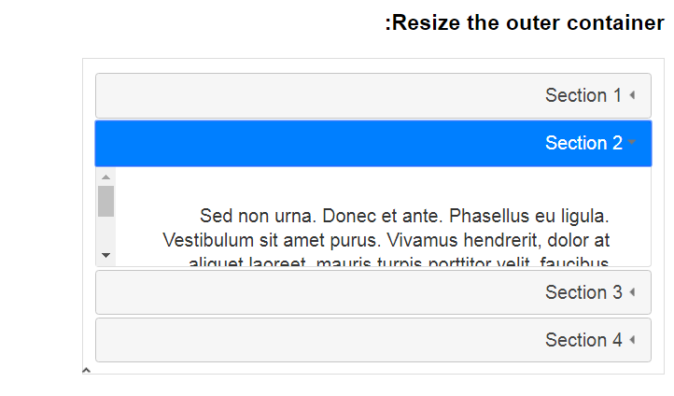

The change you need to do in the code as following:

